Youth Exchange

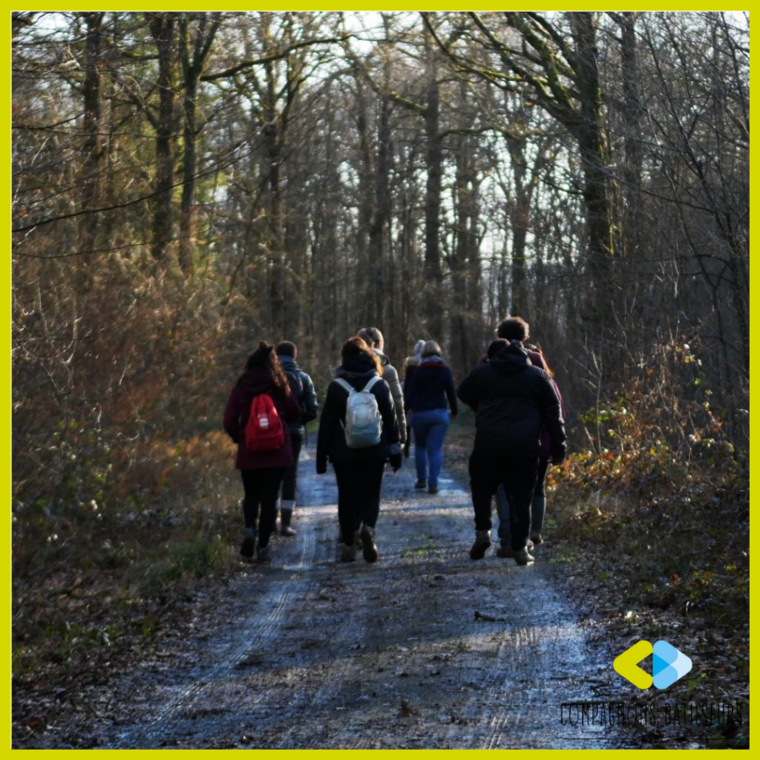
CROSSROADS

Introduction

Crossroads was born out of a discussion between young Belgians who were wondering about openness when meeting new people from different cultures.
These young people share the importance of promoting the diversity of the public on the activities and identify it as a richness to cultivate.
Through this exchange, the group of young people wishes to focus on the factors and elements that make up our identity as individuals and to make each of us more aware of the uniqueness that constitutes us.
The objective will be to address intercultural dialogue, interactions between individuals by focusing on what open-mindedness and empathetic listening really is.

The Crossroads Project

The aim of Crossroads is to bring together young people from different backgrounds, notably by inviting other nationalities to take part in the debate.
This youth exchange will aim to make young people aware that their education, and the identity they have built for themselves through this educational influence, sometimes biases their encounter with the other. They will be led to find ways to overcome the prejudices and judgments that everyone frequently makes, without always realizing it, in order to discover the other in a sincere way.
With help of non-formal education techniques, the young people will be led to develop this open-mindedness and empathetic listening.
- They will live together for the duration of the exchange at the Saint-François complex in Marche-en-Famenne (a Walloon town in Belgium). Through this cohabitation, they will share moments of informal exchanges that will allow them to create links.
- They will share moments of more formal exchange guided by themes that will create debate.
- They will learn to capture moments of reflection in front of the camera.
- They will create together a small play that will allow them to share creatively the results of their exchanges.

Target Group
The group will be composed of 25 people from 4 different nationalities:
- Belgians (host country), with 2 facilitators and 5 participants.
- Spaniards with 1 facilitator and 5 participants.
- French with 1 facilitator and 5 participants.
- Portuguese with 1 leader and 5 participants.

The young people taking part in this exchange are between 18 and 28 years old. They are determined to overcome their prejudices and share moments of exchange.

