Call for Partners:
Young Activists Performing Peace
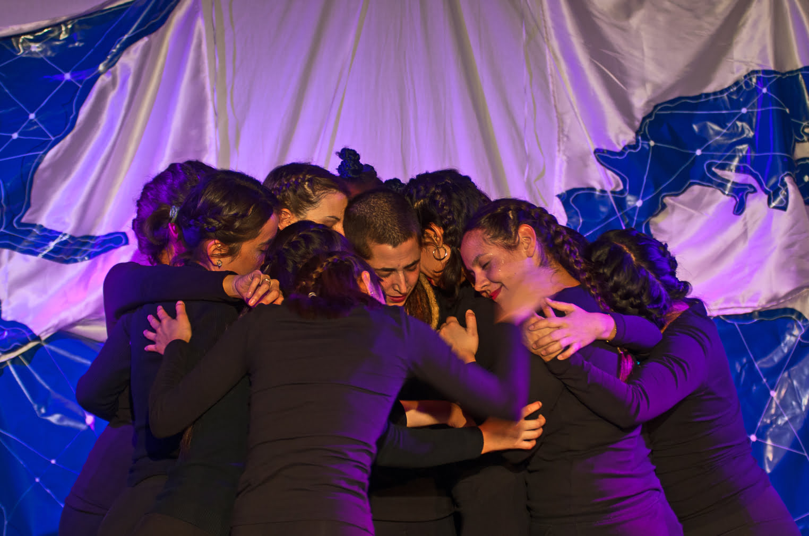
Sievershausen / Germany 23.07.-30.07.2024
Training on methodologies and peace education on civic work for youth workers, educators, and youth leaders.
Age 18 + / Language: English
Peace is fundamental to building sustainable social change for all. Today, we live in times in which our work as youth leaders and educators must foster commitment and resistance in the search for innovative and peaceful solutions for the transformation of communities. Theatre allows us to inform ourselves, to position ourselves, to put a voice of protest, to raise awareness, to take reality to another dimension, to dream utopias, to remember and not to forget. And above all, not to ignore the conflict.
In this opportunity we will share theatre tools to reflect on conflicts in different areas of our lives and learn different ways to resolve them, thus accepting diversity and promoting mutual understanding and respect for the other.
In this way we will use theatrical tools from the Theatre of the Oppressed, Epic Theatre, Biographical Theatre and corporal expression. Through the implementation of theatrical dynamics, scenic composition, and text creation, we want to provide multipliers, trainers and youth leaders with dynamic strategies to apply in the future in their groups in the different respective areas.
"We see our work as a way of defending what we believe to be fair and fighting what we believe to be unjust."
The training will consist of the following modules:
- Introduction to the subject and acting work: presentation dynamics and group cohesion; What is peace?
- Biographical Theater: The composition on stage and the vocal work; Who am I and what are my areas of interest; Identification of conflicts.
- Theater of the Oppressed: Its foundations and how it relates to peace; Identification of social privileges and disadvantages; From conflict to solutions.
- Epic Theater: The distancing effect and chorus; Positioning, protest and dialogue; Humor and irony as political tools of resistance.
- Corporal expression: Relationship between body, conflict and peace.
- Group project: Applying what we have learned on stage.
- Individual project: How to apply what I have learned in my area of work?

For more information please visit https://www.aquitheaterberlin.de

Requirements for participants:

- You have initial work experience as a trainer or team leader in non-formal or youth political education work
- You have early experience with anti-discrimination, anti-racism and conflict resolution issues.
- You are already involved or would like to be involved in educational work that promotes diversity in the future.
- You are able to recognize conflict and are open to share some of your experiences in a safe and caring space.
- You are ready to step out of your comfort zone and work in a diverse group on these topics with people who have had different experiences than you.
- You are willing to empathize with other people's experiences and deal with them in an appreciative and sensitive manner.

Around 21 young people and young adults from Europe and neighbouring countries are invited to the training. We will try to offer a safe space that celebrates diversity and does not accept any type of violence or discrimination: Diversity wins and strengthens! We therefore particularly welcome applications from people who had to flee their countries, migrated and/or confronted racism, people with disabilities and/or people from other marginalized groups as well as FLINTA*-persons.

Conditions for participation according to Erasmus + regulations

- 1 - 3 participants per organisation, from following regions: EU- Europe, Eastern Europe, Caucasus, Mediterian regions
- Age: 18+ (no upper limit)
- Working language: English
- Date of arrival 23.07.24 - in the afternoon
- Date of departure 30.07.24 – in the morning
- Location: Sievershausen near Hannover (Germany)
- The Hosting Organization of this offer will organise the accommodation and covers the costs for accommodation and food
- Participation fee: we try to adjust the fee to the purchasing power in the different countries
Fee for participants from Germany, West and North - European countries: 40,-€
Fee for participants from South and East European countries: 20,-€
- Reimbursement of the travel expenses is calculated according to the flat rate of the ERASMUS + programme. We ask the participants to use sustainable means of transport.

Contact:
Nikolaus Ell & Esma Tari
Youth Exchange , ICJA e.V. youthexchange@icja.de

